Use this page to track image usage or record descriptions. This document can be adapted for your needs and re-saved.

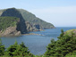 | Atlantic Image 1
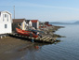 | Atlantic Image 2
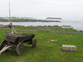 | Atlantic Image 3
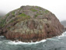 | Atlantic Image 4
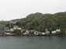 | Atlantic Image 5
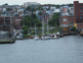 | Atlantic Image 6
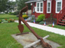 | Atlantic Image 7
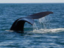 | Atlantic Image 8
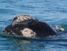 | Atlantic Image 9

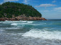 | Atlantic Image 10
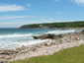 | Atlantic Image 11
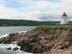 | Atlantic Image 12
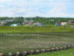 | Atlantic Image 13
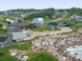 | Atlantic Image 14
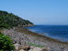 | Atlantic Image 15
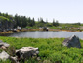 | Atlantic Image 16
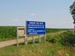 | Atlantic Image 17
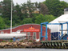 | Atlantic Image 18
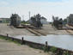 | Atlantic Image 19
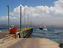 | Atlantic Image 20
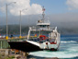 | Atlantic Image 21
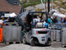 | Atlantic Image 22
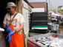 | Atlantic Image 23
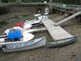 | Atlantic Image 24
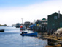 | Atlantic Image 25
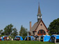 | Atlantic Image 26
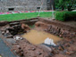 | Atlantic Image 27
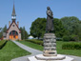 | Atlantic Image 28
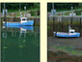 | Atlantic Image 29

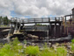 | Atlantic Image 30
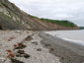 | Atlantic Image 31
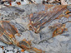 | Atlantic Image 32
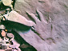 | Atlantic Image 33
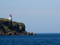 | Atlantic Image 34
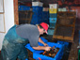 | Atlantic Image 35
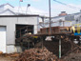 | Atlantic Image 36
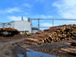 | Atlantic Image 37
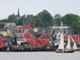 | Atlantic Image 38
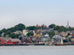 | Atlantic Image 39
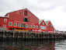 | Atlantic Image 40
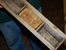 | Atlantic Image 41
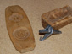 | Atlantic Image 42
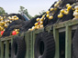 | Atlantic Image 43
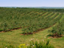 | Atlantic Image 44
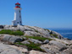 | Atlantic Image 45
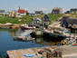 | Atlantic Image 46
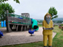 | Atlantic Image 47
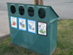 | Atlantic Image 48
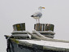 | Atlantic Image 49

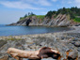 | Atlantic Image 50
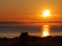 | Atlantic Image 51
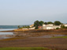 | Atlantic Image 52
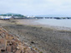 | Atlantic Image 53
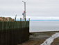 | Atlantic Image 54
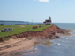 | Atlantic Image 55

