Use this page to track image usage or record descriptions. This document can be adapted for your needs and re-saved.

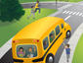 | Home, School, and Community Image 1
 | Home, School, and Community Image 2
 | Home, School, and Community Image 3
 | Home, School, and Community Image 4
 | Home, School, and Community Image 5
 | Home, School, and Community Image 6
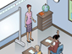 | Home, School, and Community Image 7
 | Home, School, and Community Image 8
 | Home, School, and Community Image 9

 | Home, School, and Community Image 10
 | Home, School, and Community Image 11
 | Home, School, and Community Image 12
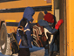 | Home, School, and Community Image 13
 | Home, School, and Community Image 14
 | Home, School, and Community Image 15
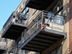 | Home, School, and Community Image 16
 | Home, School, and Community Image 17
 | Home, School, and Community Image 18
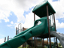 | Home, School, and Community Image 19
 | Home, School, and Community Image 20
 | Home, School, and Community Image 21
 | Home, School, and Community Image 22
 | Home, School, and Community Image 23
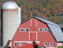 | Home, School, and Community Image 24
 | Home, School, and Community Image 25
 | Home, School, and Community Image 26
 | Home, School, and Community Image 27
 | Home, School, and Community Image 28
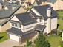 | Home, School, and Community Image 29

 | Home, School, and Community Image 30
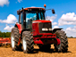 | Home, School, and Community Image 31
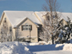 | Home, School, and Community Image 32
 | Home, School, and Community Image 33
 | Home, School, and Community Image 34
 | Home, School, and Community Image 35
 | Home, School, and Community Image 36
 | Home, School, and Community Image 37
 | Home, School, and Community Image 38
 | Home, School, and Community Image 39
 | Home, School, and Community Image 40

