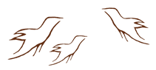

Introduction to Walking Together

About the Resource

Walking Together: First Nations, Métis and Inuit Perspectives in Curriculum was designed to
- show the holistic nature of First Nations, Métis and Inuit ways of knowing
- provide an opportunity to share perspectives on topics raised in consultations with First Nation, Métis and Inuit communities
- demonstrate First Nation, Métis and Inuit perspectives in teaching and learning experiencess

Talking Together is a discussion guide that accompanies the resource.

Consultation Cycle for Walking Together
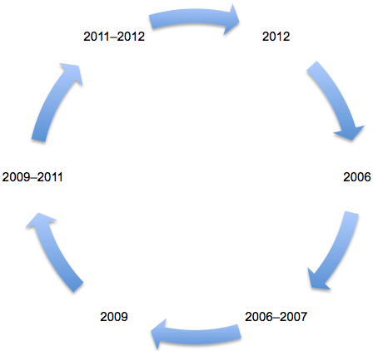
2006 Stage 1: Initiation
First Nation, Métis and Inuit community representatives suggest the establishment of a culturally authentic and historically accurate resource to help educators understand First Nation, Métis and Inuit perspectives.
2006–2007 Stage 2: Research
Consultation with First Nation, Métis and Inuit community representatives across Alberta results in development of topic areas and gathering of resource content.

2009 Stage 3: Planning
A program plan is presented to the First Nation, Métis and Inuit Advisory Committee for feedback and suggestions.
2009–2011 Stage 4: Development
Collaborative development of the resource proceeds with contributions from First Nation, Métis and Inuit community members.

2011–2012 Stage 5: Verification
The draft resource is shared with First Nation, Métis and Inuit community members and contributors for review of authenticity and accuracy.
2012 Stage 6: Maintenance
Consultation with First Nation, Métis and Inuit community members continues in order to ensure that resource content is culturally authentic and historically accurate.
Resource Review Principles

These principles are adapted from the Western and Northern Canadian Protocol Guidelines:
- First Nation, Métis and Inuit persons knowledgeable of the culture and content participate in development and/or validation/approval of resources.
- Presentation of the traditions and experiences of First Nation, Métis and Inuit through word and image is placed in an appropriate context so as to be culturally authentic and historically accurate rather than romanticized.
- Accurate contemporary and traditional information and images are presented in order to show that First Nation, Métis and Inuit and their cultures are dynamic, diverse and evolving.

Images and Design

Design decisions for this resource are the result of many discussions with First Nation, Métis and Inuit advisory groups.

The changing background landscapes on the Home Page speak to the changing, dynamic nature of First Nation, Métis and Inuit cultures.

The leather-motif header with glyphs inspired by rock art pictographs visually acknowledges and honours tradition in this contemporary technological setting.

The circle of stones used as navigation buttons to the topic areas conveys traditional meanings:
- The circle indicates that all things are equal, that we share the world with others.
- The circle connects to the medicine wheels and tipi rings found across Alberta, indicating a sharing of place-based knowledge.
- Rock and stones, considered to be the “old ones,” carry story and information; in both a figurative and qualitative sense, they pass knowledge on to those who have the gift and who are willing to listen.

Topic Areas and Sections
