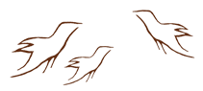
Appreciative Inquiry
Asset Mapping Tool

Check off all the programs and resources available in your school or community. Try to be specific and identify known resources that fit into the categories on the checklist.

First Nation, Métis and Inuit Parent Networks
Details:

First Nation, Métis and Inuit mentors and peer groups
Details:

Self-awareness assistance
Details:

Native Liaison Worker (school-based or district-based)
Details:

Native Friendship Centre (community-based)
Details:

Online networking (e.g., social media groups, Professional Learning Networks)
Details:

Community partnerships (e.g., First Nations Education Authority, Métis Settlement Council)
Details:

Other (i.e., community or regional organizations)
Details:

