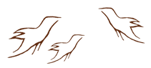
Aboriginal and Treaty Rights
How
When
Why
What
Where
Who
Observing Practice Activity
5Ws Graphic Organizer: Aboriginal and Treaty Rights

