 | What We Know | What We Want to Find Out | What We Learned | How Can I Use What We Learned?
Who is an Elder?
What is the role of an Elder?
What protocols are
used to invite an Elder into the classroom?
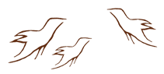
Observing Practice Activity
K-W-L-H Chart: Elders

