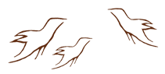
Respecting Wisdom Activity
K-W-L-H Chart: Healing Historical Trauma

Residential Schools

What do we know? | What do we want to learn? | What did we learn?  (from Respecting Wisdom videos) | How can we learn more?  (in addition to Respecting Wisdom videos)
Outline some of the ways in which this knowledge supports classroom practices:

