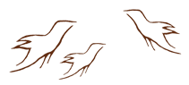
Observing Practice Activity
The Compass Rose: Worldviews
A Comparison of Indigenous and Western Worldviews

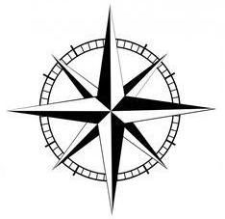
Well-being
Relationships
Place
Knowledge

