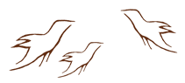
Observing Practice Activity
Placemat Activity: Indigenous Pedagogy

In a group of four, brainstorm ways of incorporating Indigenous pedagogy into the classroom environment. Each participant records his or her ideas in an outer section of the topic wheel. As a group, participants decide on the best four ideas and record them in the centre.

