CLUSTER | TMT: Trades, Manufacturing & Transportation
OCCUPATION | Construction
KEY | SAFE SHOP LAYOUT
1. shop/lab door  2. fire extinguisher  3. first aid kit  4. sink  5. storage – towels  6. power shut-off switch  7. whiteboard  8. SmartBoard/projector  9. bulletin board  10. broom, dustpan storage  11. PPE storage  12. class doors between rooms  13. eyewash station  14. fire exit doors  15. rip table saw  16. crosscut/dado table saw  17. compound mitre saw 12”  18. jointer 12”  19. planer 24”  20. planer 15”  21. scroll saw  22. large bandsaw (resaw blade)  23. bandsaw 14”  24. drill press  25. lathe  26. disc/belt sander  27. edge sander  28. drum sander (dual drum 24”)  29. router table  30. workbench/power tool storage  31. hand tool board  32. clamping/glue-up table  33. vacuum veneering table  34. panel saw  35. CNC machine 24” x 36”  36. CAD lab (6 stations)  37. plywood storage rack  38. lumber storage rack  39. student workbench 24” x 48”  40. grinder/sharpening bench  41. teacher demonstration bench  42. student storage lockers  43. office  44. clamp rack  45. loading bay  46. finishing room/spray booth (with fume hood)  47. dust collection/humidity control/ storage room  48. spindle sander | 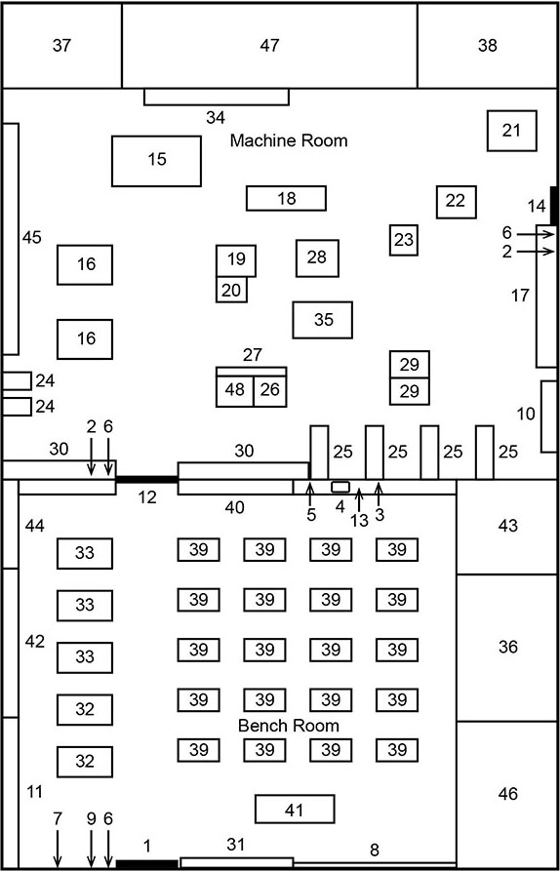

Notes:
- Safety glass partition half-walls between bench room, machine room, finishing room (46), CAD Lab (36), and office (43)
- Ideally would include an open raised mezzanine for additional storage.
- Machine Room and Bench Room should be equipped with a humidity control system to keep 40% relative humidity all year.

