CLUSTER | MDC: MEDIA, DESIGN, & COMMUNICATION ARTS
OCCUPATION | Communications Technology
HAZARD CONTROLS | CONSUMABLE—CHROMA WET
Engineering Controls | 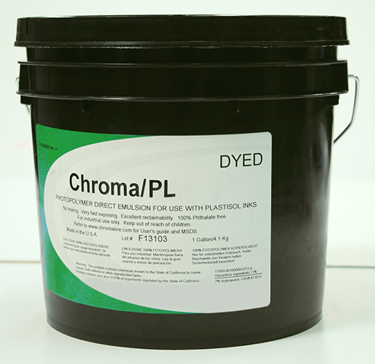
- proper ventilation
- proper storage
Administrative Controls
- Ensure that students have completed a mandatory orientation to print screening tasks.

- Follow the school safety policy.
- Tag and remove defective tools from service.

- Schedule work to avoid overcrowding.

- Ensure repetitive tasks are properly paced.

- Post important emergency telephone numbers and contacts.

- Post lockdown procedures.

- Post fire drill procedures.

- Establish handwashing practices.

- Ensure fire extinguishers are strategically located and marked.

- Provide a first aid kit and supplies, including an eyewash station and biohazard disposal.

- Keep the manufacturer’s manual for the chroma wet.

- Provide an ergonomically appropriate work area.

- Ensure that correct lighting is available.

- Correctly place and maintain smoke detectors and heat sensors.

- Ensure WHMIS training is available. Ensure that students can identify WHMIS workplace labels that warn people about the dangers of a product and provide information needed to safely handle a product.
- Maintain a Material Safety Data Sheets (MSDS) binder that gives detailed information about the chemicals used in print making.

- Properly label each chemical jug. Make sure to highlight the danger symbols and spell out what to avoid and what to do if contact is made.
Personal Protective Equipment (PPE)
- safety splash goggles (CSA approved)
- protective apron
- protective gloves

