CLUSTER | MDC: MEDIA, DESIGN, & COMMUNICATION ARTS
OCCUPATION | Communications Technology
HAZARD CONTROLS | CONSUMABLE—FIXER (PHOTO DEVELOPMENT)
Engineering Controls | 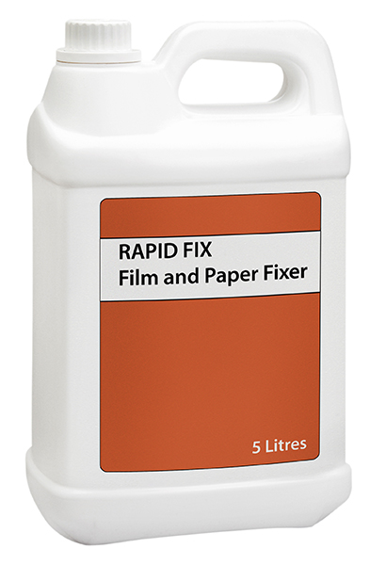  Adapted from © aris sanjaya/9393535/Fotolia
- good ventilation in the darkroom
Administrative Controls
- Follow the school safety policy.

- Schedule work to avoid overcrowding.

- Ensure repetitive tasks are properly paced.

- Post important emergency telephone numbers and contacts.

- Post lockdown procedures.

- Post fire drill procedures.

- Establish handwashing practices.

- Ensure fire extinguishers are strategically located and marked.

- Provide a first aid kit and supplies, including an eyewash station and biohazard disposal.

- Keep the manufacturer’s instructions for fixer.

- Provide an ergonomically appropriate work area.

- Ensure that correct lighting is available.

- Correctly place and maintain smoke detectors and heat sensors.

- Ensure WHMIS training is available.
- Maintain a Material Safety Data Sheets (MSDS) binder that gives detailed information about the chemicals used in photography and print making.

- Create steps for using the darkroom. For example:
Before you start:
- Close the darkroom door and turn on safety lights.
- Put on an apron.
- Wash two sets of tongs.
- Add water to Tray 3.

Developer:
- Place developer in Tray 1.
- Place photo in Tray 1 with the shiny side up.
- Gently slosh the developer in Tray 1 back and forth for about 1 minute to immerse the photo.
- Use tongs to remove photo from Tray 1.

Fixer:
- Add fixer to Tray 2.
- Using tongs, place photo in Tray 2.
- Remove photo from tray using different tongs than those used with developer.

Water:
- Place photo in Tray 3.
- Leave photo in Tray for 3 minutes. Rinse and remove photo using tongs.
- Hang photo to dry.

When you are done:
- Wipe up the sink area.
- Cover Tray 1 (developer) and Tray 2 (fixer) with black plastic covers.
- Wash both sets of tongs.
- Empty water from Tray 3.

Instruct students to store dry photos.
Personal Protective Equipment (PPE)
- protective splash goggles (CSA approved)
- gloves
- apron

