CLUSTER | MDC: MEDIA, DESIGN, & COMMUNICATION ARTS
OCCUPATION | Communications Technology
HAZARD CONTROLS | TOOL—GORILLAPOD
Engineering Controls | 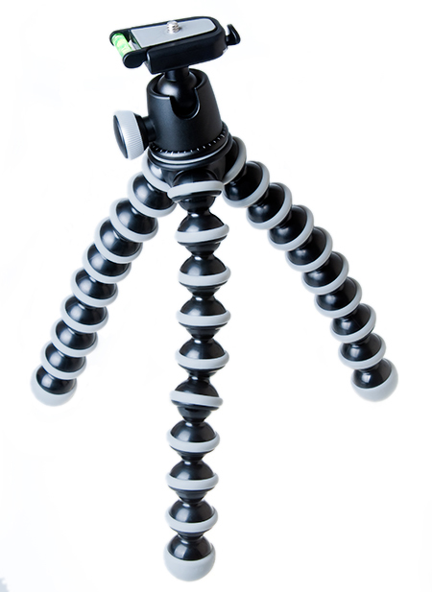  © Photoseeker/shutterstock
- n/a
Administrative Controls
- Provide initial training to include a thorough review of hazards and accidents associated with the job.
- Follow the school safety policy.
- Provide and document ongoing safety education and training, including mandatory equipment and tool orientation.
- Tag and remove defective tools from service.

- Schedule work to avoid overcrowding.

- Ensure repetitive tasks are properly paced.

- Post important emergency telephone numbers and contacts.

- Post lockdown procedures.

- Post fire drill procedures.

- Establish handwashing practices.

- Ensure fire extinguishers are strategically located and marked.

- Provide a first aid kit and supplies, including an eyewash station and biohazard disposal.

- Keep the manufacturer’s manual for the tool.

- Provide an ergonomically appropriate work area.

- Ensure that correct lighting is available.

- Correctly place and maintain smoke detectors and heat sensors.
Personal Protective Equipment (PPE)
- n/a

