CLUSTER | MDC: MEDIA, DESIGN, & COMMUNICATION ARTS
OCCUPATION | Communications Technology
HAZARD CONTROLS | CONSUMABLES—INKS (FOR PAPER AND FABRIC PROJECTS, SUCH AS PLASTISOL INK)
Engineering Controls | 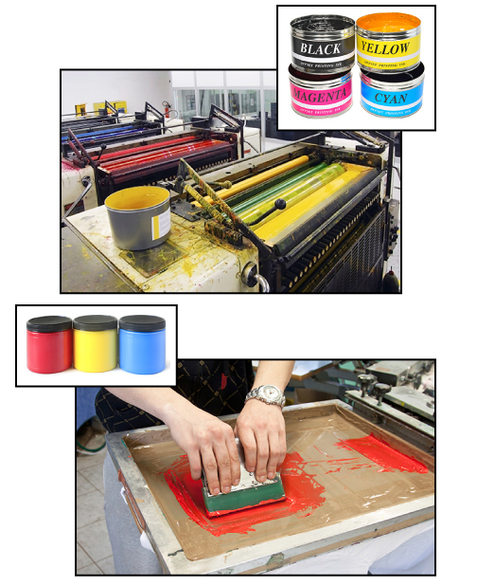CMYK ink tins: © axway/36808686/Fotolia; printing press, ink jars, and silkscreening: iStockphoto/Thinkstock
- proper ventilation
- proper storage
Administrative Controls
- Ensure WHMIS training is available. Ensure that students can identify WHMIS workplace labels that warn people about the dangers of a product and provide information needed to safely handle a product.

- Follow the school safety policy.
- Schedule work to avoid overcrowding.
- Ensure repetitive tasks are properly paced.
- Post important emergency telephone numbers and contacts.
- Post lockdown procedures.
- Post fire drill procedures.
- Establish handwashing practices.
- Ensure fire extinguishers are strategically located and marked.
- Provide a first aid kit and supplies, including an eyewash station and biohazard disposal.
- Keep the manufacturers’ manuals for the inks.
- Provide an ergonomically appropriate work area.
- Ensure that correct lighting is available.
- Correctly place and maintain smoke detectors and heat sensors.

- Maintain a Material Safety Data Sheets (MSDS) binder that gives detailed information about the chemicals used in photography and print making.

- Properly label each chemical jug. Make sure to highlight the danger symbols and spell out what to avoid and what to do if contact is made.
Personal Protective Equipment (PPE)
- work gloves
- safety splash goggles (CSA approved)

