CLUSTER | MDC: MEDIA, DESIGN, AND COMMUNICATION ARTS
OCCUPATION | Fashion
HAZARD CONTROLS | CONSUMABLES—ADHESIVES
Engineering Controls | 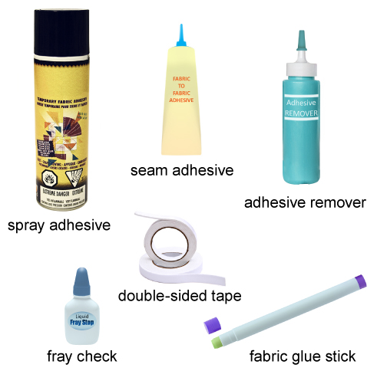  seam adhesive: adapted from © AXL/shutterstock  fray check: adapted from © Olga Kovalenko/shutterstock  fabric glue stick: adapted from © design56/shutterstock  double-sided tape: © Freer/shutterstock  adhesive remover: adapted from © KITSANANAN/shutterstock
- proper ventilation for spray-type adhesives and adhesives with strong odors
Administrative Controls
- Provide adequate instruction on lab routines, job procedures, and equipment operation.
- Post safety signage.

- Keep the work area clean and tidy at all times.
- Follow the manufacturer’s directions for maintenance and safe practices.
- Inspect adhesives regularly to ensure safe use.
- Tag and remove defective materials from service.
- Arrange the gluing area to permit safe, efficient work practices and ease of movement and clean-up.
- Schedule work to avoid overcrowding.

- Pay attention to work.
- Ensure adequate lighting over work area.
- Ensure ergonomic setup of equipment.
- Protect the work surface from drips by placing something (such as a plate) beneath the tip or nozzle of the adhesive applicator.
- Use the right adhesive for the job.

- Follow the school safety policy.

- Provide and document ongoing safety education and training, including mandatory equipment and tool orientation.

- Ensure tools are used under competent supervision.

- Ensure repetitive tasks are properly paced.

- Post important emergency telephone numbers and contacts.

- Post lockdown procedures.

- Post fire drill procedures.

- Establish handwashing practices.

- Ensure fire extinguishers are strategically located and marked.

- Provide a first aid kit and supplies, including an eyewash station and biohazard disposal.

- Correctly place and maintain smoke detectors and heat sensors.
Personal Protective Equipment (PPE)
- safety gloves, depending on the task

