CLUSTER | MDC: MEDIA, DESIGN, AND COMMUNICATION ARTS
OCCUPATION | Fashion
HAZARD CONTROLS | EQUIPMENT—COMPUTER AND PRINTER
Engineering Controls | 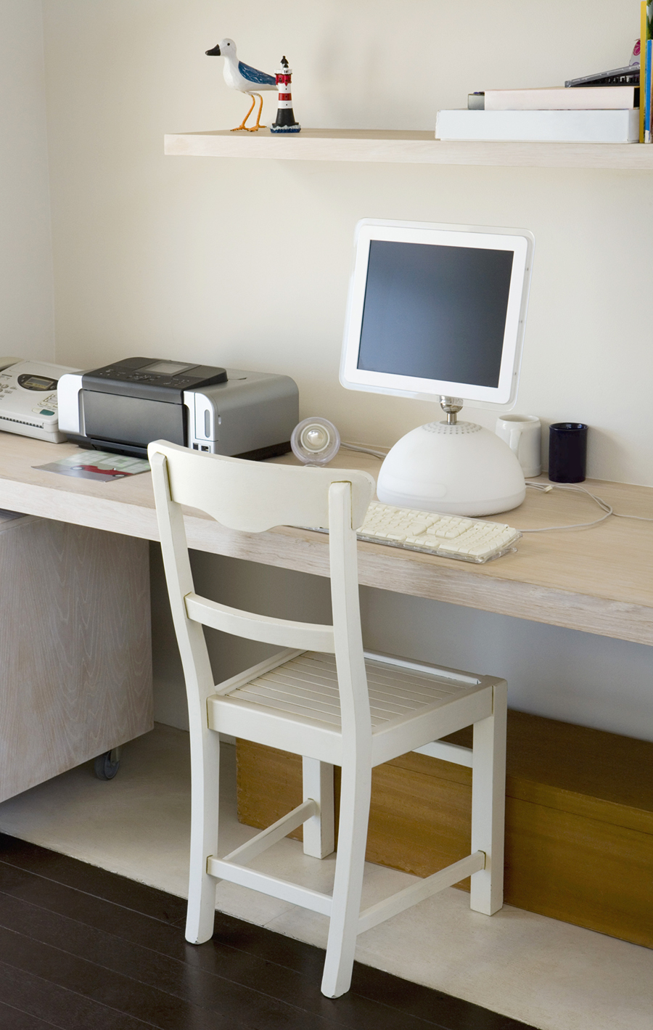  Goodshoot/Thinkstock
- n/a
Administrative Controls
- Provide adequate instruction on lab routines, job procedures, and equipment operation.
- Follow the manufacturer’s directions for operation, maintenance, and safe practices.

- Keep the work area clean and tidy at all times.
- Prevent cords from becoming trip hazards in high-traffic areas.
- Tag and remove defective equipment from service.
- Arrange the equipment to permit safe, efficient work practices and ease of movement and clean-up.

- Plug the cord into computer first, and then plug the cord into the socket.
- Keep food and beverages away from the equipment.

- Sanitize the keyboard.
- Inspect cords and plugs for fraying and exposed wires.
- Ensure that correct lighting is available.
- Ensure an ergonomic set-up of the equipment and furniture.

- Follow the school safety policy.

- Provide and document ongoing safety education and training, including mandatory equipment and tool orientation.

- Ensure equipment is used under competent supervision.

- Ensure repetitive tasks are properly paced.

- Post important emergency telephone numbers and contacts.

- Post lockdown procedures.

- Post fire drill procedures.

- Establish handwashing practices.

- Ensure fire extinguishers are strategically located and marked.

- Provide a first aid kit and supplies, including an eyewash station and biohazard disposal.

- Correctly place and maintain smoke detectors and heat sensors.
Personal Protective Equipment (PPE)
- wrist rest
- adjustable chair

