CLUSTER | MDC: MEDIA, DESIGN, AND COMMUNICATION ARTS
OCCUPATION | Fashion
HAZARD CONTROLS | TOOLS—SCISSORS AND OTHER CUTTING TOOLS
Engineering Controls | 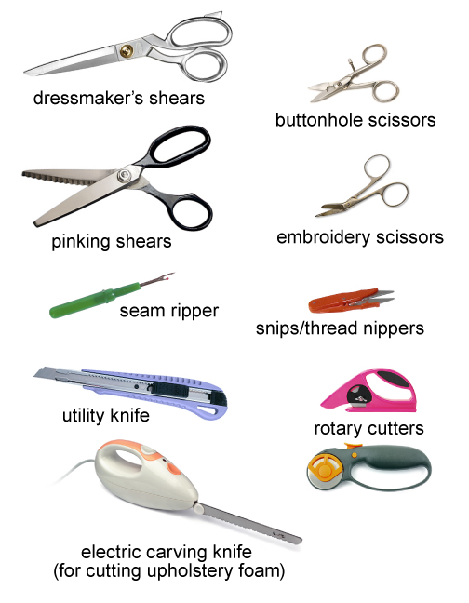  dressmaker's shears: iStockphoto/Thinkstock  pinking shears: adapted from iStockphoto/Thinkstock  seam ripper: Hemera Technologies/PhotoObjects.net/Thinkstock  utility knife: adapted from iStockphoto/Thinkstock  electric knife: © Coprid/shutterstock  buttonhole scissors: iStockphoto/Thinkstock  embroidery scissors: iStockphoto/Thinkstock  thread nippers: adapted from © Joyce Wilkes/3486589/Fotolia  rotary cutters: adapted from © AlexAvich/shutterstock and © Louella938/shutterstock
- n/a
Administrative Controls
- Provide adequate instruction on lab routines, job procedures, and equipment operation.

- Keep the work area clean and tidy at all times.
- Post safety signage.
- Follow the manufacturer’s directions for operation, maintenance, and safe practices.
- Inspect the tools regularly to ensure safe operation.

- Sharpen tools when needed.
- Ensure a clear line of sight of all students.
- Prevent cords from becoming trip hazards in high-traffic areas.
- Tag and remove defective tools from service.
- Arrange the work area to permit safe, efficient work practices and ease of movement and clean-up.
- Provide a container to dispose of sharp objects (e.g., blades).
- Work at a safe speed.
- Ensure that correct lighting is provided.
- Ensure ergonomic set-up of the cutting surface and furniture.
- Ensure the right tool and the right cutting surface is used for the job.

- Pass scissors to others closed with the handle first.

- Close the rotary cutter when not in use.

- Do not cut through pins. Doing so may damage the equipment or tool.
- Instruct students to always cut away from their body at all times.
- Plug the cord into the appliance first, and then plug the cord into the socket.
- Keep food and beverages away from the electrical tools.
- Inspect the cords and plugs for fraying and exposed wires.

- Follow the school safety policy.

- Provide and document ongoing safety education and training, including mandatory equipment and tool orientation.

- Ensure tools are used under competent supervision.

- Ensure repetitive tasks are properly paced.

- Post important emergency telephone numbers and contacts.

- Post lockdown procedures.

- Post fire drill procedures.

- Establish handwashing practices.

- Ensure fire extinguishers are strategically located and marked.

- Provide a first aid kit and supplies, including an eyewash station and biohazard disposal.

- Correctly place and maintain smoke detectors and heat sensors.
Personal Protective Equipment (PPE)
- safety glasses or eye protection, if needed

