CLUSTER | MDC: MEDIA, DESIGN, AND COMMUNICATION ARTS
OCCUPATION | Fashion
HAZARD CONTROLS | EQUIPMENT—EMBROIDERY MACHINE
Engineering Controls | 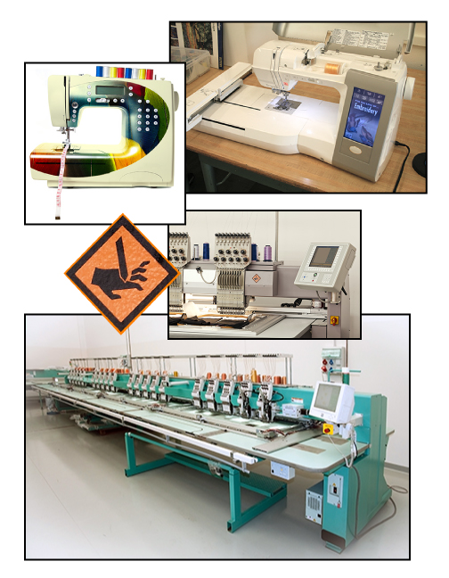  combination sewing/embroidery machine  industrial embroidery machine  Clockwise left to right:  © byheaven/30896182/Fotolia  © 2013 Alberta Education  © srki66/42945514/Fotolio  © Moreno Soppelsa/shutterstock  adapted from © srki66/42945514/Fotolio
- n/a
Administrative Controls
- Provide adequate instruction on lab routines, job procedures, and equipment operation.
- Keep the work area clean and tidy at all times.
- Post safety signage.
- Follow the manufacturer’s directions for operation, threading, maintenance, and safe practices.
- Inspect the machine regularly to ensure safe operation.
- Ensure a clear line of sight of all students on machines.
- Prevent cords from becoming trip hazards in
high-traffic areas.
- Tag and remove defective equipment from service.
- Arrange equipment to permit safe, efficient work practices and ease of movement and clean-up.

- Make adjustments to the machine when the machine is stopped.
- Plug the cord into the appliance first, and then plug the cord into the socket.
- Keep food and beverages away from the machine.
- Keep hands away from the light or the needle.
- Inspect the cords and plugs for fraying and exposed wires.
- Check the settings before you start.

- Work at a safe speed.
- Ensure that correct lighting is provided.
- Ensure ergonomic set-up of machine and furniture.
- Use the right needle for the chosen fabric and stabilizer weight.
- Choose the proper-sized hoop for the embroidery area.

- Follow the school safety policy.

- Provide and document ongoing safety education and training, including mandatory equipment and tool orientation.

- Ensure tools are used under competent supervision.

- Ensure repetitive tasks are properly paced.

- Post important emergency telephone numbers and contacts.

- Post lockdown procedures.

- Post fire drill procedures.

- Establish handwashing practices.

- Ensure fire extinguishers are strategically located and marked.

- Provide a first aid kit and supplies, including an eyewash station and biohazard disposal.

- Correctly place and maintain smoke detectors and heat sensors.
Personal Protective Equipment (PPE)
- safety glasses or eye protection

