CLUSTER | MDC: MEDIA, DESIGN, AND COMMUNICATION ARTS
OCCUPATION | Fashion
HAZARD CONTROLS | TOOL—GLUE GUN
Engineering Controls | 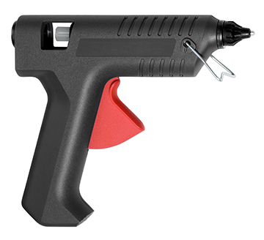  iStockphoto/Thinkstock
- n/a
Administrative Controls
- Provide adequate instruction on lab routines, job procedures, and equipment operation.
- Keep the work area clean and tidy at all times.
- Post safety signage.
- Follow the manufacturer’s directions for operation, maintenance, and safe practices.
- Inspect equipment regularly to ensure safe operation.
- Prevent cords from becoming trip hazards in high-traffic areas.
- Tag and remove defective equipment from service.
- Arrange the work area to permit safe, efficient work practices and ease of movement and clean-up.
- Schedule work to avoid overcrowding

- Use the correct glue stick for the equipment and the task, and make sure the glue stick is inserted correctly.
- Keep food and beverages away from the tool.
- Inspect the cords and plugs for fraying and exposed wires.
- Ensure correct lighting is provided.
- Ensure ergonomic set-up of equipment.

- Do not touch the hot glue.
- Ensure that a plate of some sort is located under the nozzle to collect drips.

- Follow the school safety policy.

- Provide and document ongoing safety education and training, including mandatory equipment and tool orientation.

- Ensure tools are used under competent supervision.

- Ensure repetitive tasks are properly paced.

- Post important emergency telephone numbers and contacts.

- Post lockdown procedures.

- Post fire drill procedures.

- Establish handwashing practices.

- Ensure fire extinguishers are strategically located and marked.

- Provide a first aid kit and supplies, including an eyewash station and biohazard disposal.

- Correctly place and maintain smoke detectors and heat sensors.
Personal Protective Equipment (PPE)
- safety gloves, depending on the task
- close-toed shoes

