CLUSTER | MDC: MEDIA, DESIGN, AND COMMUNICATION ARTS
OCCUPATION | Fashion
HAZARD CONTROLS | EQUIPMENT—IRON AND IRONING BOARD
Engineering Controls | 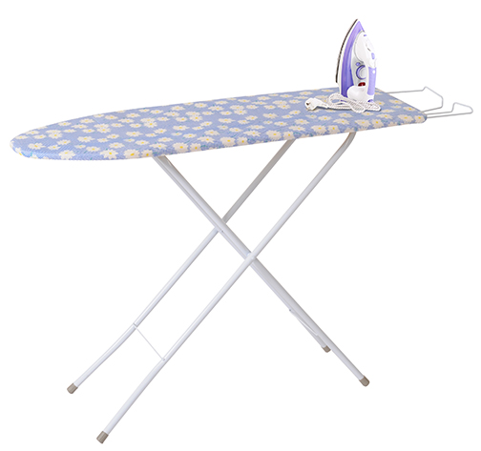  iron and ironing board (domestic)  adapted from © Africa Studio/44454294/Fotolia and Hemera/Thinkstock
- n/a
Administrative Controls
- Provide adequate instruction on lab routines, job procedures, and equipment operation.
- Keep the work area clean and tidy at all times.
- Post safety signage.
- Follow the manufacturer’s directions for operation, maintenance, and safe practices.
- Inspect the iron and ironing board regularly to ensure safe operation.

- Use bottled water in the iron.

- Clean up water spills when filling the water reservoir of the iron.

- Remove cooled water from the iron before storing the iron.
- Ensure a clear line of sight of all students on equipment using heat sources.
- Prevent cords from becoming trip hazards in
high-traffic areas.
- Tag and remove defective equipment from service.
- Arrange the equipment and the work area to permit safe, efficient work practices and ease of movement and clean-up.

- Make temperature adjustments to the iron before you start. Use the correct temperature setting for the chosen fabric.
- Plug the cord into the appliance first, and then plug the cord into the socket.
- Keep food and beverages away from the iron and ironing board.
- Use a well-balanced, rigid ironing board that has a well-padded and tight-fitting iron cover.
- Keep hands away from soleplate and steam vents.
- Inspect the cord and plugs for fraying and exposed wires.
- Ensure correct lighting is provided.
- Ensure ergonomic set-up of the heat source and furniture.

- Follow the school safety policy.

- Provide and document ongoing safety education and training, including mandatory equipment and tool orientation.

- Ensure equipment is used under competent supervision.

- Ensure repetitive tasks are properly paced.

- Post important emergency telephone numbers and contacts.

- Post lockdown procedures.

- Post fire drill procedures.

- Establish handwashing practices.

- Ensure fire extinguishers are strategically located and marked.

- Provide a first aid kit and supplies, including an eyewash station and biohazard disposal.

- Correctly place and maintain smoke detectors and heat sensors.
Personal Protective Equipment (PPE)
- n/a

