CLUSTER | MDC: MEDIA, DESIGN, AND COMMUNICATION ARTS
OCCUPATION | Fashion
HAZARD CONTROLS | EQUIPMENT—SERGER MACHINE
Engineering Controls | 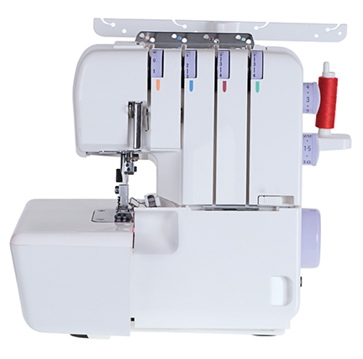  © slon1971/shutterstock  Note: The foot pedal and power cord are not shown.
- n/a
Administrative Controls
- Provide adequate instruction on lab routines, job procedures, and equipment operation.
- Keep the work area clean and tidy at all times.
- Post safety signage and threading instructions.
- Follow the manufacturer’s directions for operation, maintenance, and safe practices.
- Inspect the machine regularly to ensure safe operation.
- Ensure a clear line of sight of all students on machines.
- Prevent the cord and foot pedal from becoming trip hazards.
- Tag and remove defective equipment from service.
- Arrange machines and the work area to permit safe, efficient work practices and ease of movement and clean-up.

- Make adjustments to the machine when the machine is stopped and turned off.
- Plug the cord into the appliance first, and then plug the cord into the socket.
- Keep food and beverages away from the machine.
- Keep hands away from the light and the needle.

- Keep fingers and pins away from the machine blade.
- Inspect the cords and plugs for fraying and exposed wires.
- Check the settings before you start.
- Work at a safe speed.
- Ensure correct lighting is provided.
- Ensure ergonomic set-up of machine and furniture.

- Ensure needles are correctly installed.
- Use the right needle(s) for the chosen fabric weight.

- Follow the school safety policy.

- Provide and document ongoing safety education and training, including mandatory equipment and tool orientation.

- Ensure tools are used under competent supervision.

- Ensure repetitive tasks are properly paced.

- Post important emergency telephone numbers and contacts.

- Post lockdown procedures.

- Post fire drill procedures.

- Establish handwashing practices.

- Ensure fire extinguishers are strategically located and marked.

- Provide a first aid kit and supplies, including an eyewash station and biohazard disposal.

- Correctly place and maintain smoke detectors and heat sensors.
Personal Protective Equipment (PPE)
- safety glasses or eye protection

