CLUSTER | MDC: MEDIA, DESIGN, AND COMMUNICATION ARTS
OCCUPATION | Fashion
HAZARD CONTROLS | EQUIPMENT—SEWING MACHINE
Engineering Controls | 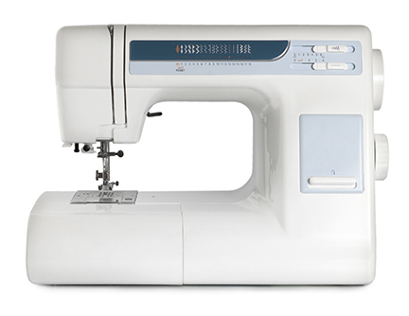  iStockphoto/Thinkstock  Note: The foot pedal and power cord are not shown.
- n/a
Administrative Controls
- Provide adequate instruction on lab routines, job procedures, and equipment operation.

- Keep the work area clean and tidy at all times.

- Post safety signage.

- Follow the manufacturer’s directions for operation, maintenance, and safe practices.

- Inspect the machine regularly to ensure safe operation.

- Ensure a clear line of sight of all students on machines.

- Prevent cords from becoming trip hazards in high-traffic areas.

- Tag and remove defective from service.

- Arrange machines and the work area to permit safe, efficient work practices and ease of movement and clean-up.

- Make adjustments to the sewing machine when the machine is stopped and turned off.

- Plug the cord into the appliance first, and then plug the cord into the socket.

- Keep food and beverages away from the machine.

- Keep hands or fingers away from light and needle.

- Ensure that the bobbin is in and wound correctly.

- Inspect the cords and plugs for fraying and exposed wires.

- Check the settings on the sewing machine before you start.

- Work at a safe speed.

- Ensure correct lighting is provided.

- Ensure ergonomic set-up of machine and furniture.

- Use the right needle for the chosen fabric weight.

- When finished, remove the cord. Then close and cover the machine carefully to avoid damaging the cord.

- Follow the school safety policy.

- Provide and document ongoing safety education and training, including mandatory equipment and tool orientation.

- Ensure tools are used under competent supervision.

- Ensure repetitive tasks are properly paced.

- Post important emergency telephone numbers and contacts.

- Post lockdown procedures.

- Post fire drill procedures.

- Establish handwashing practices.

- Ensure fire extinguishers are strategically located and marked.

- Provide a first aid kit and supplies, including an eyewash station and biohazard disposal.

- Correctly place and maintain smoke detectors and heat sensors.
Personal Protective Equipment (PPE)
- safety glasses or eye protection

