CLUSTER | MDC: MEDIA, DESIGN, AND COMMUNICATION ARTS
OCCUPATION | Fashion
HAZARD CONTROLS | TOOLS—KNITTING NEEDLES AND OTHER SHARP, POINTED TOOLS
Engineering Controls | 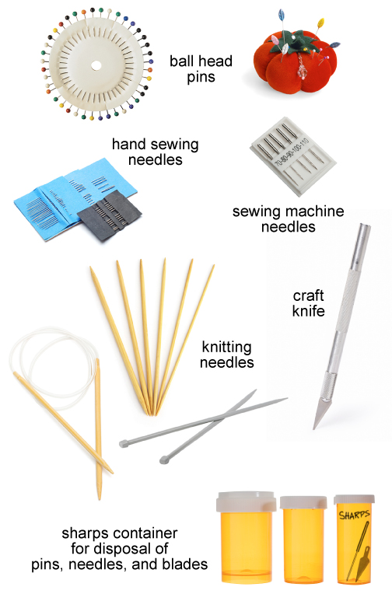pins: Stockbyte/Thinkstock  craft knife, pin cushion, machine needles, hand needles, and knitting needles: iStockphoto/Thinkstock  pill bottles: Creatas/Thinkstock
- n/a
Administrative Controls
- Provide adequate instruction on lab routines, job procedures, and equipment operation.

- Keep the work area clean and tidy at all times. For example, pick up pins if dropped on the floor.

- Do not put pins in your mouth.

- Post safety signage.

- Follow the manufacturer’s directions for operation, maintenance, and safe practices.

- Inspect tools regularly to ensure safe operation.

- Discard bent, burred, or broken sharp tools (e.g., needles, blades, rippers, and pins) in sharps container.

- Ask the students to report defective tools to the teacher.

- Ensure a clear line of sight of all students.

- Ensure sharp tools are sharpened.

- Work at a safe speed.

- Ensure correct lighting is provided.

- Work at a safe speed.

- Ensure the right tool is used for the job.

- Follow the school safety policy.

- Provide and document ongoing safety education and training, including mandatory equipment and tool orientation.

- Ensure tools are used under competent supervision.

- Ensure repetitive tasks are properly paced.

- Post important emergency telephone numbers and contacts.

- Post lockdown procedures.

- Post fire drill procedures.

- Establish handwashing practices.

- Ensure fire extinguishers are strategically located and marked.

- Provide a first aid kit and supplies, including an eyewash station and biohazard disposal.

- Correctly place and maintain smoke detectors and heat sensors.
Personal Protective Equipment (PPE)
- safety glasses or safety goggles, depending on the task

