CLUSTER | MDC: MEDIA, DESIGN, AND COMMUNICATION ARTS
OCCUPATION | Fashion
HAZARD CONTROLS | CONSUMABLES—TEXTILE TESTING MATERIALS
Engineering Controls | 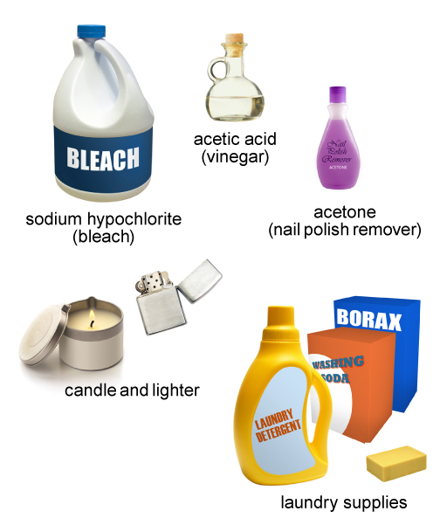  bleach: adapted from © Beth Van Trees/shutterstock  vinegar: adapted from © Nikola Bilic/shutterstock  acetone: adapted from © travis manley/shutterstock  candle: © Eli Maier/shutterstock  lighter: adapted from © akesak/shutterstock  bar of soap: adapted from © EloPaint/shutterstock  yellow jug: adapted from © restyler/shutterstock  borax and washing soda: adapted from © Antonio Jorge Nunes/shutterstock
- adequate ventilation
Administrative Controls
- Provide adequate instruction on lab routines, job procedures, and equipment operation.

- Keep the work area clean and tidy at all times.

- Post safety signage.

- Inspect the supplies and the equipment regularly to ensure safe use.

- Remove defective materials and equipment from service.

- Arrange materials and the work area to permit safe, efficient work practices and ease of movement and clean-up.

- Do not mix different brands of chemicals or supplies.

- Schedule work to avoid overcrowding.

- Keep food and beverages away from the work area.

- Ensure that correct lighting is provided.

- Ensure ergonomic set-up of equipment.

- Ensure that a sink is available.

- Follow the school safety policy.

- Provide and document ongoing safety education and training, including mandatory equipment and tool orientation.

- Ensure tools are used under competent supervision.

- Ensure repetitive tasks are properly paced.

- Post important emergency telephone numbers and contacts.

- Post lockdown procedures.

- Post fire drill procedures.

- Establish handwashing practices.

- Ensure fire extinguishers are strategically located and marked.

- Provide a first aid kit and supplies, including an eyewash station and biohazard disposal.

- Correctly place and maintain smoke detectors and heat sensors.

- Provide up-to-date MSDS.

- Ensure WHMIS training is available.

- Properly label products.
Personal Protective Equipment (PPE)
- safety or rubber gloves, depending on the task
- safety glasses, depending on the task
- apron
- close-toed shoes

