CLUSTER | NAT: NATURAL RESOURCES
OCCUPATION | Agriculture
HAZARD CONTROLS | CONSUMABLES—CHEMICALS
Engineering Controls | 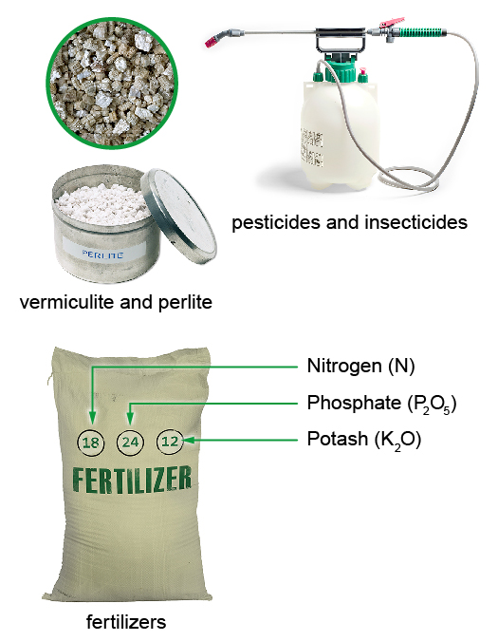  fertilizer bag adapted from © WinaiTepsuttinun/42319047/Fotolia  vermiculite: iStockphoto/Thinkstock  perlite: Hemera Technologies/PhotoObjects.net/Thinkstock  spray wand: Hemera/Thinkstock
- dry, ventilated area to store chemicals
Administrative Controls
- Provide initial training to include a thorough review of hazards and accidents associated with the job.
- Follow the school safety policy.
- Provide and document ongoing safety education and training, including mandatory equipment and tool orientation.
- Ensure WHMIS training is available.
- Provide up-to-date SDS.
- Read the SDS for product use.
- Read the directions for mixing or administering the product.

- Ensure repetitive tasks are properly paced.

- Provide a first aid kit and supplies, including an eyewash station and biohazard disposal.

- Secure and use the least toxic and harmful substance for the students and the environment.

- Properly label controlled products.

- Provide proper storage for chemicals.

- Instruct students on proper lifting techniques.

- Establish handwashing practices.
Personal Protective Equipment (PPE)
- eye protection (CSA approved)
- protective mask
- gloves
- coveralls

