CLUSTER | NAT: NATURAL RESOURCES
OCCUPATION | Agriculture
HAZARD CONTROLS | TOOLS—CUTTING TOOLS
Engineering Controls | 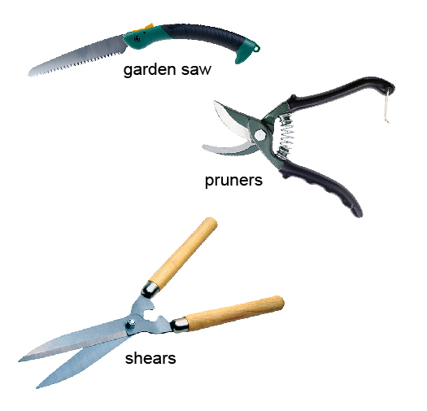  saw: Hemera/Thinkstock; pruners: Ryan McVay/Photodisc/Thinkstock; shears: Ingram Publishing/Thinkstock
- locking blades
Administrative Controls
- Provide initial training to include a thorough review of hazards associated with the job.
- Follow the school safety policy.
- Provide and document ongoing safety education and training, including mandatory equipment and tool orientation.
- Be aware of sharp edges.

- Always point the blade or tip toward the ground when you are carrying a tool.

- Clean the tool when you are finished using it.

- Lock the blades when storing the tool.

- Tag and remove defective tools from service.

- Ensure tools are used under competent supervision.

- Ensure the tool is appropriate for the work to be done.

- Ensure repetitive tasks are properly paced.

- Provide a first aid kit and supplies, including an eyewash station and biohazard disposal.

- Keep the manufacturer’s manual for the tools.

- Keep sharp tools sharpened.

- Establish handwashing practices.
Personal Protective Equipment (PPE)
- work gloves
- eye protection (CSA approved)

