CLUSTER | NAT: NATURAL RESOURCES
OCCUPATION | Agriculture
HAZARD CONTROLS | EQUIPMENT—LAWN MOWER
Engineering Controls | 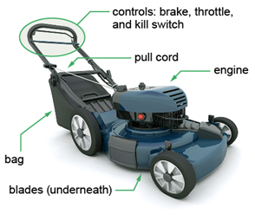  Adapted from © Kirsty Pargeter/29103418/Fotolia
- quick-release shutoff
Administrative Controls
- Provide initial training to include a thorough review of hazards and accidents associated with the job.
- Follow the school safety policy.
- Provide and document ongoing safety education and training, including mandatory equipment and tool orientation.
- Review the parts of the lawn mower before starting.

- Never start a gas lawn mower in an enclosed area. Always start a gas lawn mower in a ventilated area (preferably outside).

- Stand behind the lawn mower when starting the engine.

- Practise starting and turning off the engine before actually using the mower.

- Never add fuel to a hot motor.

- Keep extra fuel in appropriate containers in ventilated storage areas.

- Always use properly rated electrical cords for electric lawn mowers.

- When using an electric lawn mower, always be aware of the location of the electric cord.

- Never use a cord that has exposed wires.

- Tag and remove defective equipment from service.

- Ensure equipment is used under competent supervision.

- Ensure the equipment is appropriate for the work to be done.

- Ensure repetitive tasks are properly paced.

- Provide a first aid kit and supplies, including an eyewash station and biohazard disposal.

- Keep the manufacturer’s manual for the equipment.

- Adhere to the Canadian Electrical Code during the operation, repair, and maintenance of equipment.

- Keep the blades sharpened.

- Establish handwashing practices.
Personal Protective Equipment (PPE)
- heavy-duty gloves
- steel-toed shoes/boots (CSA approved)
- eye protection (CSA approved)
- hearing protection
- coveralls

