CLUSTER | NAT: NATURAL RESOURCES
OCCUPATION | Agriculture
HAZARD CONTROLS | TOOLS—LONG-HANDLED TOOLS (sod lifter, garden weasel, hoe, shovel, rake, spade, fork, edger)
Engineering Controls | 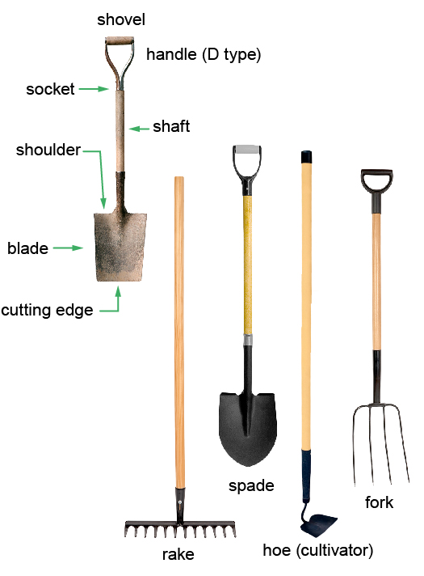  shovel: adapted from © Yio/25236024/Fotolia  rake and fork: © photka/41323545/Fotolia  spade: Hemera/Thinkstock  hoe: Hemera/Thinkstock
- n/a
Administrative Controls
- Provide initial training to include a thorough review of hazards and accidents associated with the job.
- Follow the school safety policy.

- Provide and document ongoing safety education and training, including mandatory equipment and tool orientation.
- Ensure the tool is in proper working order; e.g., the handle is not loose or cracked. Tag and remove defective tools from service.

- Leave enough room around the person using the tool to allow leverage.

- Always clean the tool and store it properly when you are finished using it.

- Ensure tools are used under competent supervision.

- Ensure the tool is appropriate for the work to be done.

- Ensure repetitive tasks are properly paced.

- Provide a first aid kit and supplies, including an eyewash station and biohazard disposal.

- Establish handwashing practices.
Personal Protective Equipment (PPE)
- heavy-duty gloves

