CLUSTER | NAT: NATURAL RESOURCES
OCCUPATION | Agriculture
HAZARD CONTROLS | EQUIPMENT—ROTARY TILLER
Engineering Controls | 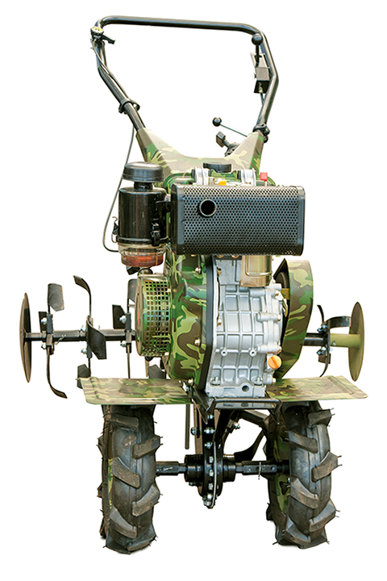  Adapted from © Dja65/shutterstock
- shut-off switch
- brake
- clutch
Administrative Controls
- Provide initial training to include a thorough review of hazards and accidents associated with the job.
- Follow the school safety policy.

- Provide and document ongoing safety education and training, including mandatory equipment and tool orientation.
- Review the parts of a rotary tiller before starting.

- Never start a rotary tiller in an enclosed area. Always start a rotary tiller in a ventilated area (preferably outside).

- Stand behind the rotary tiller when starting the engine.

- Practise starting and turning off the engine before actually using the tiller.

- Keep extra fuel in appropriate containers in ventilated storage areas.

- Never add fuel to a hot motor.

- Tag and remove defective equipment from service.

- Ensure equipment is used under competent supervision.

- Ensure the equipment is appropriate for the work to be done.

- Ensure repetitive tasks are properly paced.

- Provide a first aid kit and supplies, including an eyewash station and biohazard disposal.

- Keep the manufacturer’s manual for the equipment.

- Keep the blades sharpened.
- Establish handwashing practices.
Personal Protective Equipment (PPE)
- heavy-duty gloves
- steel-toed shoes/boots (CSA approved)
- eye protection (CSA approved)
- hearing protection
- coveralls

