CLUSTER | NAT: NATURAL RESOURCES
OCCUPATION | Agriculture
HAZARD CONTROLS | MATERIALS—SEED TRAYS AND POTS
Engineering Controls | 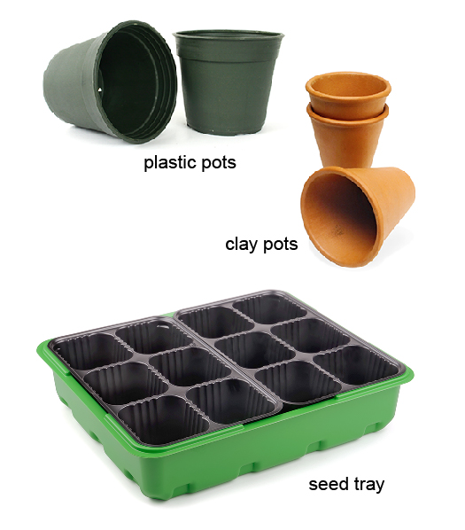  plastic pots: Hemera/Thinkstock; clay pots: Stockbyte /Thinkstock; seed tray: © Coprid/39713633/Fotolia
- n/a
Administrative Controls
- Be careful with sharp edges.

- Seed trays and pots may be heavy when full. Instruct students on proper lifting techniques.

- Follow the school safety policy.

- Provide a first aid kit and supplies, including an eyewash station and biohazard disposal.

- Establish handwashing practices.
Personal Protective Equipment (PPE)
- apron
- gloves

