CLUSTER | NAT: NATURAL RESOURCES
OCCUPATION | Agriculture
HAZARD CONTROLS | TOOLS—SHORT-HANDLED TOOLS
Engineering Controls | 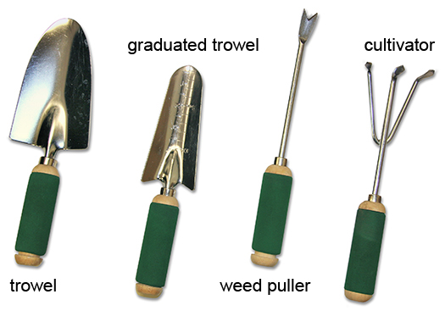
- n/a
Administrative Controls
- Be aware of any hazards that may be in your working area.

- Be aware of sharp edges.

- Always point the blade or tip toward the ground when you are carrying a tool.

- Clean the tool when you are finished using it.

- Follow the school safety policy.

- Provide and document ongoing safety education and training, including mandatory equipment and tool orientation.

- Tag and remove defective tools from service.

- Ensure tools are used under competent supervision.

- Ensure the tool is appropriate for the work to be done.

- Ensure repetitive tasks are properly paced.

- Provide a first aid kit and supplies, including an eyewash station and biohazard disposal.

- Establish handwashing practices.
Personal Protective Equipment (PPE)
- work gloves
- knee pads (optional)

