CLUSTER | NAT: NATURAL RESOURCES
OCCUPATION | Agriculture
HAZARD CONTROLS | TOOLS—WATERING CAN AND HOSE
Engineering Controls | 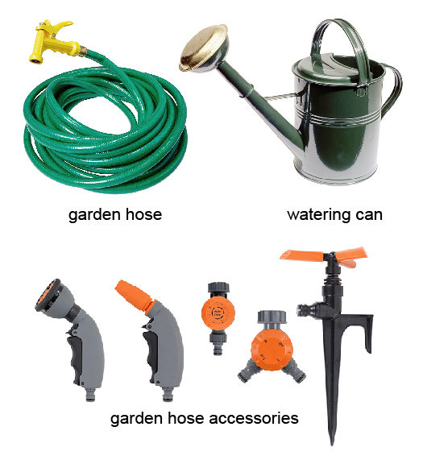  hose and watering can: Ryan McVay/Photodisc/Thinkstock; accessories: © Yanas/shutterstock
- n/a
Administrative Controls
- Use extension nozzles for hard-to-reach places.

- Be careful not to slip on water spilled on the floor.

- Follow the school safety policy.

- Ensure repetitive tasks are properly paced.

- Provide a first aid kit and supplies, including an eyewash station and biohazard disposal.

- Establish handwashing practices.
Personal Protective Equipment (PPE)
- protective shoes/rubber boots
- apron

