CLUSTER | NAT: NATURAL RESOURCES
OCCUPATION | Agriculture
HAZARD CONTROLS | EQUIPMENT—WHEELBARROW
Engineering Controls | 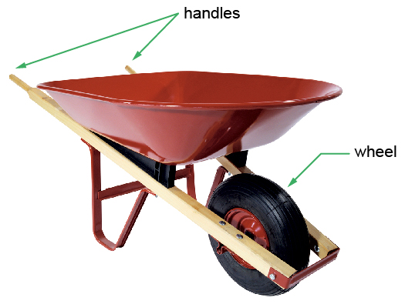  Ryan McVay/Photodisc/Thinkstock
- n/a
Administrative Controls
- Provide initial training to include a thorough review of hazards and accidents associated with the job.
- Do not overload the wheelbarrow.

- Keep the load balanced in the wheelbarrow.

- Stand behind the wheelbarrow when moving material.

- Follow the school safety policy.

- Provide and document ongoing safety education and training, including mandatory equipment and tool orientation.

- Tag and remove defective equipment from service.

- Ensure equipment is used under competent supervision.

- Ensure the equipment is appropriate for the work to be done.

- Ensure repetitive tasks are properly paced.

- Provide a first aid kit and supplies, including an eyewash station and biohazard disposal.

- Keep the manufacturers’ manual for the equipment.

- Instruct students on proper lifting techniques.

- Establish handwashing practices.
Personal Protective Equipment (PPE)
- heavy-duty gloves
- steel-toed shoes/boots (CSA approved)
- eye protection (CSA approved)
- coveralls

