CLUSTER | NAT: NATURAL RESOURCES
OCCUPATION | Forestry
HAZARD CONTROLS | TOOL—30-M TAPE
Engineering Controls | 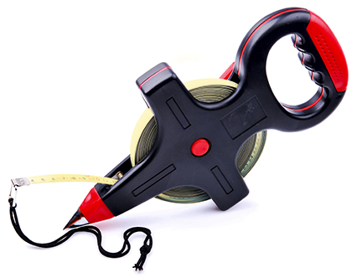  © iluzia/33334707/Fotolia
- n/a
Administrative Controls
- Follow the school safety policy.
- Provide initial training to include a thorough review of hazards and accidents associated with the job.
- Provide and document ongoing safety education and training, including mandatory equipment and tool orientation.
- Tag and remove defective tools from service.
- Ensure the tool is appropriate for the work to be done.
- Provide a first aid kit and supplies, including an eyewash station and biohazard disposal.
- Keep the manufacturer’s manual for the tool. Read and follow manufacturer instructions, precautions, and directions for proper safety, maintenance, and cleaning.
- Develop and communicate safe work practices and procedures for hazardous situations.
- Practise using a 30-m tape in a safe environment.
Personal Protective Equipment (PPE)
- proper footwear, depending on the task
- eye protection
- high-visibility jacket or vest when in forest

