CLUSTER | NAT: NATURAL RESOURCES
OCCUPATION | Forestry
HAZARD CONTROLS | TOOL—HAND PRUNERS
Engineering Controls | 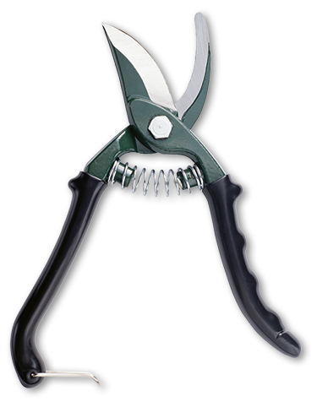  Ryan McVay/Photodisc/Thinkstock
- locking blades
- availability of “handed” versions (for left-hand or right-hand use)
Administrative Controls
- Be aware of sharp edges.

- Always point the blade or tip toward the ground when you are carrying a tool.

- Clean the tool when you are finished using it.

- Lock the blades when storing the tool.
- Follow the school safety policy.

- Provide and document ongoing safety education and training, including mandatory equipment and tool orientation.

- Tag and remove defective tools from service.

- Ensure tools are used under competent supervision.

- Ensure the tool is appropriate for the work to be done.

- Ensure repetitive tasks are properly paced.

- Provide a first aid kit and supplies, including an eyewash station and biohazard disposal.

- Keep the manufacturer’s manual for the tools.

- Keep sharp tools sharpened.
Personal Protective Equipment (PPE)
- work gloves
- eye protection (CSA approved)
- hard hat
- protective footwear
- high-visibility jacket or vest when in forest

