CLUSTER | NAT: NATURAL RESOURCES
OCCUPATION | Forestry
HAZARD CONTROLS | TOOL—HANDSAW
Engineering Controls | 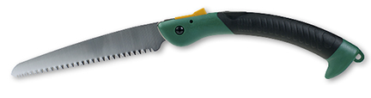  Hemera/Thinkstock
- n/a
Administrative Controls
- Provide initial training to include a thorough review of hazards and accidents associated with the job.
- Follow the school safety policy.
- Provide and document ongoing safety education and training, including mandatory equipment and tool orientation.
- Tag and remove defective tools from service.
- Ensure tools are used under competent supervision.
- Ensure the tool is appropriate for the work to be done; e.g., select a saw of proper shape and size for stock being used and select a saw with the number of teeth per inch (TPI) in order to get the desired finish.

- Choose a saw handle that keeps your wrist in a natural position in the horizontal plane.
- Hold the stock being cut firmly in place. Use a vise or supporting bench for longer stock.
- Protect the teeth of the saw with a machine guard when not in use.
- Keep the manufacturer’s manual for the tool. Read and follow the manufacturer instructions, precautions, and directions for proper safety, maintenance, and cleaning.
- Establish handwashing practices.
- Develop and communicate safe work practices and procedures for hazardous situations.
- Ensure repetitive tasks are properly paced.
- Provide a first aid kit and supplies, including an eyewash station and biohazard disposal.
- Keep sharp tools sharpened.
Personal Protective Equipment (PPE)
- protective gloves
- polycarbonate or plastic safety glasses or face shield
- protective footwear
- respirator

