CLUSTER | NAT: NATURAL RESOURCES
OCCUPATION | Forestry
HAZARD CONTROLS | TOOL—PLANTING BAG
Engineering Controls | 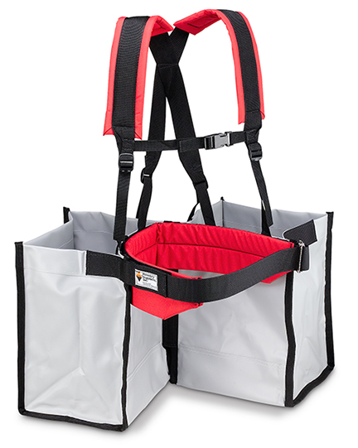  © Forestry Suppliers, Inc. Used by permission. 580077. http://www.forestry-suppliers.com (April, 2013)
- Choose a bag with a waist strap and two shoulder straps.
Administrative Controls
- Provide initial training to include a thorough review of hazards and accidents associated with the job.
- Follow the school safety policy.
- Provide and document online safety education and training, including mandatory equipment and tool orientation.
- Ensure the tool is appropriate for the work to be done; e.g., make sure the planting bag is the right size for the person wearing it, has appropriate capacity, and is weighted evenly.
- Be sure the weight can be carried comfortably by the wearer.
- Fasten and adjust all straps.
- Read and follow the manufacturer’s instructions, precautions, and directions for proper fit, capacity, safety, maintenance, and cleaning.
- Provide adequate instruction on loading and carrying the bag safely.
- Establish handwashing practices.
- Develop and communicate safe work practices and procedures for hazardous situations.
- Ensure repetitive tasks are properly paced.
- Provide a first aid kit and supplies, including an eyewash station and biohazard disposal.
- Ensure that long hair is tied back and/or secured under a hat.

Personal Protective Equipment (PPE)
- protective gloves
- proper footwear
- high-visibility jacket or vest when in the forest

