CLUSTER | NAT: NATURAL RESOURCES
OCCUPATION | Forestry
HAZARD CONTROLS | MATERIAL—PROTECTIVE MULCH
Engineering Controls | 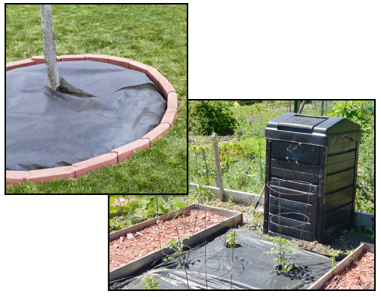  left: Adapted from © oocoskun/42236496/Fotolia,  right: Adapted from © Alison Hancock/shutterstock
- n/a
Administrative Controls
- Provide initial training to include a thorough review of hazards and accidents associated with the job.
- Follow the school safety policy.
- Provide and document ongoing safety education and training, including mandatory equipment and tool orientation.
- Follow the manufacturer’s instructions, precautions, and directions for proper use.
- Establish handwashing practices.
- Develop and communicate safe work practices and procedures for physically demanding work.
- Secure and use the least toxic and harmful substance for the students and the environment.
- Choose the most appropriate type of mulch depending on the environment.
- Train students to distribute mulch safely.
- Ensure repetitive tasks are properly paced.

- Provide a first aid kit and supplies, including an eyewash station and biohazard disposal.
Personal Protective Equipment (PPE)
- protective gloves
- respirator
- proper footwear
- high-visibility jacket or vest if in the forest

