CLUSTER | NAT: NATURAL RESOURCES
OCCUPATION | Forestry
HAZARD CONTROLS | Equipment—Protective Tube
Engineering Controls | 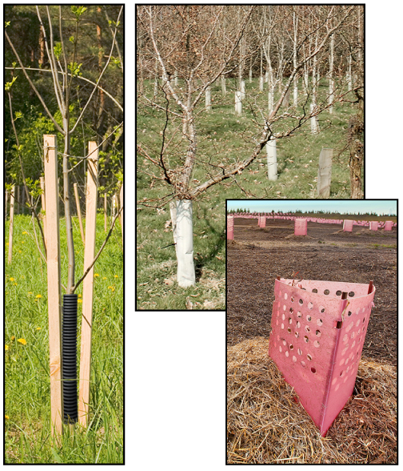  left: Adapted from © Kitch Bain/shutterstock and  © Burdika/shutterstock  middle: © David Fowler/shutterstock;  right: © Steve Lovegrove/35507717/Fotolia.com
- n/a
Administrative Controls
- Provide initial training to include a thorough review of hazards and accidents associated with the job.
- Follow the school safety policy.
- Provide and document ongoing safety education and training, including mandatory equipment and tool orientation.
- Read and follow the manufacturer’s instructions, precautions, and directions for proper use, safety, maintenance, and cleaning.
- Establish handwashing practices.
- Develop and communicate safe work practices and procedures for hazardous situations.
- Secure and use the least toxic and harmful substance for the students and the environment.
- Ensure repetitive tasks are properly paced.
- Provide a first aid kit and supplies, including an eyewash station and biohazard disposal.
Personal Protective Equipment (PPE)
- protective gloves
- polycarbonate or plastic glasses
- hardhat (if other are working overhead)
- protective footwear
- high-visibility jacket or vest when in the forest

