CLUSTER | NAT: NATURAL RESOURCES
OCCUPATION | Forestry
HAZARD CONTROLS | Tool—Pruning Shears AND Loppers
Engineering Controls | 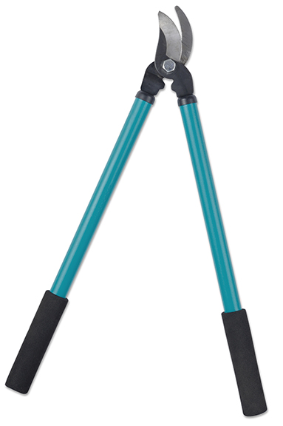  iStockphoto/Thinkstock
- handles made of non-conducting material
Administrative Controls
- Provide initial training to include a thorough review of hazards and accidents associated with the job.
- Follow the school safety policy.
- Provide and document ongoing safety education and training, including mandatory equipment and tool orientation.
- Tag and remove defective tools from service.
- Ensure tools are used under competent supervision.
- Ensure the tool is appropriate for the work to be done.
- Keep the manufacturer’s manual for the tool. Read and follow the manufacturer instructions, precautions, and directions for proper safety, maintenance, and cleaning.
- Provide a first aid kit and supplies, including an eyewash station and biohazard disposal.
- Establish handwashing practices.
- Develop and communicate safe work practices and procedures for hazardous situations.
- Ensure repetitive tasks are properly paced.
- Ensure that students wear safe attire: no loose clothing or jewellery should be worn.
- Ensure that long hair is tied back and/or secured under a hat.
- Contact the power utility company before working on trees near power lines and arrange for ways to protect students (e.g., shutting off the power to the lines and grounding the trees or using insulating blankets on the trees).
- Know the minimum working distances from live power lines based on the voltage that the power lines are conducting.
- See the Tree Trimming page on the Canadian Centre for Occupational Health and Safety website (http://www.ccohs.ca/
oshanswers/safety_haz
/landscaping/tree_trimming.html).
Personal Protective Equipment (PPE)
- protective gloves
- hardhat
- hearing protection
- polycarbonate or plastic protective glasses
- protective footwear with slip-resistant soles
- close-fitting, long-sleeved clothing

