CLUSTER | NAT: NATURAL RESOURCES
OCCUPATION | Forestry
HAZARD CONTROLS | Material—Seedlings
Engineering Controls | 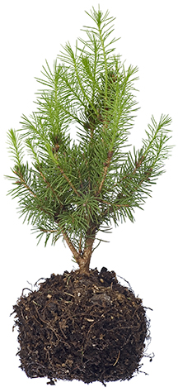  © Barna Tanko/shutterstock
- n/a
Administrative Controls
- Provide initial training to include a thorough review of hazards and accidents associated with the job.
- Follow the school safety policy.
- Provide and document ongoing safety education and training, including mandatory equipment and tool orientation.
- Read and follow the manufacturer’s instructions, precautions, and directions for proper safety, maintenance, and cleaning.
- Establish handwashing practices.
- Develop and communicate safe work practices and procedures for hazardous situations.
- Ensure repetitive tasks are properly paced.
- Provide a first aid kit and supplies, including an eye wash station and biohazard disposal.

Personal Protective Equipment (PPE)
- latex gloves or hypoallergenic alternative
- glasses or goggles
- protective footwear
- barrier mask
- face shield
- high-visibility jacket or vest when in the forest

