CLUSTER | NAT: NATURAL RESOURCES
OCCUPATION | Forestry
HAZARD CONTROLS | Material—Seeds
Engineering Controls | 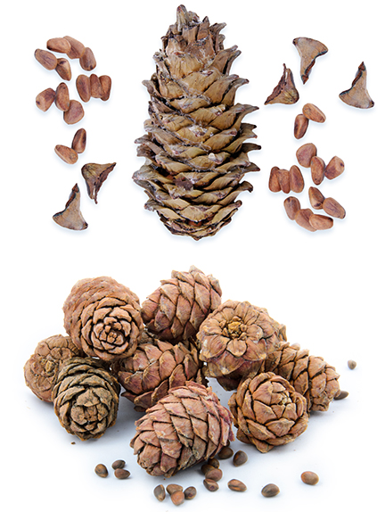  top: © papa1266/shutterstock  bottom: © zakharov aleksey/shutterstock
- n/a
Administrative Controls
- Provide initial training to include a thorough review of hazards and accidents associated with the job.
- Follow the school safety policy.
- Provide and document ongoing safety education and training, including mandatory equipment and tool orientation.
- Be sure no one is allergic to the type of seed being planted.
- Read and follow the manufacturer’s instructions, precautions, and directions for proper and safe planting.
- Establish handwashing practices.
- Provide a first aid kit and supplies, including an eye wash station and biohazard disposal.
- Choose hypoallergenic options whenever possible.
Personal Protective Equipment (PPE)
- protective gloves

