CLUSTER | NAT: NATURAL RESOURCES
OCCUPATION | Forestry
HAZARD CONTROLS | Tool—Shovel
Engineering Controls | 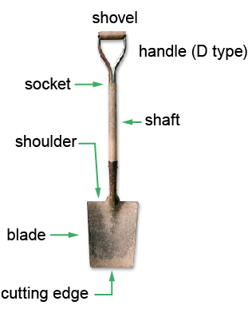  © Yio/25236024/Fotolia  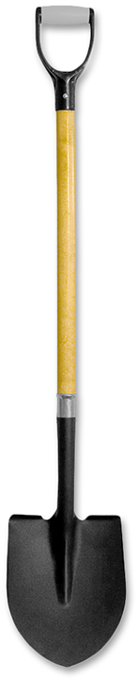  spade  Hemera/Thinkstock
- n/a
Administrative Controls
- Provide initial training to include a thorough review of hazards and accidents associated with the job.
- Follow the school safety policy.
- Provide and document ongoing safety education and training, including mandatory equipment and tool orientation.
- Ensure the tool is in proper working order; e.g., make sure that the handle is not loose or cracked. Tag and remove defective tools from service.
- Ensure tools are used under competent supervision.
- Ensure the tool is appropriate for the work to be done. The shovel should be the right size for the student, be lightweight, and have a straight handle.
- Choose softer ground for digging, when possible.
- Read and follow the manufacturer’s instructions, precautions, and directions for proper safety, maintenance, and cleaning.
- Establish handwashing practices.
- Develop and communicate safe work practices and procedures for hazardous situations.
- Ensure repetitive tasks are properly paced.
- Provide a first aid kit and supplies, including an eyewash station and biohazard disposal.
Personal Protective Equipment (PPE)
- heavy-duty gloves
- steel-capped footwear
- high-visibility jacket or vest when in the forest

