CLUSTER | NAT: NATURAL RESOURCES
OCCUPATION | Forestry
HAZARD CONTROLS | TOOL—TELESCOPING POWER PRUNERS
Engineering Controls | 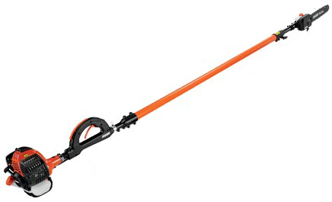  © Echo. http://www.echo-usa.com/Home (April, 2013)
- well-ventilated storage area (if gas unit)
Administrative Controls
- Provide initial training to include a thorough review of hazards and accidents associated with the job.
- Follow the school safety policy.
- Provide and document ongoing safety education and training, including mandatory equipment and tool orientation.
- Tag and remove defective tools from service.
- Ensure tools are used under competent supervision.
- Ensure the tool is appropriate for the work to be done.
- Read and follow the manufacturer instructions, precautions, and directions for proper safety, maintenance, and cleaning.
- Establish handwashing practices.
- Develop and communicate safe work practices and procedures for hazardous situations.
- Ensure repetitive tasks are properly paced.
- Provide a first aid kit and supplies, including an eyewash station and biohazard disposal.
- Contact the power utility company before working on trees near power lines to arrange for ways to protect the students (e.g., shutting off the power to the lines and grounding the trees or using insulating blankets on the trees).
- Know the minimum working distances from live power lines based on the voltage the power lines are conducting.
- Wear rubber gloves when using a pole pruner.
- Ensure that the pole pruner's cutting head is connected to the lever at the lower end of the pole with a polypropylene rope. Do not use a wire or chain.
- Keep away from heat, spark, open flame, and other ignition sources.
- For more information, see the Tree Trimming page at http://www.ccohs.ca/
oshanswers/safety_haz/landscaping
/tree_trimming.html.
Personal Protective Equipment (PPE)
- polycarbonate or plastic protective glasses
- leather gauntlet gloves
- respirator
- hearing protection
- protective footwear with slip-resistant soles
- close-fitting, long-sleeved clothing
- high-visibility jacket or vest when in the forest

