CLUSTER | NAT: NATURAL RESOURCES
OCCUPATION | Forestry
HAZARD CONTROLS | TOOL—WEDGES
Engineering Controls | 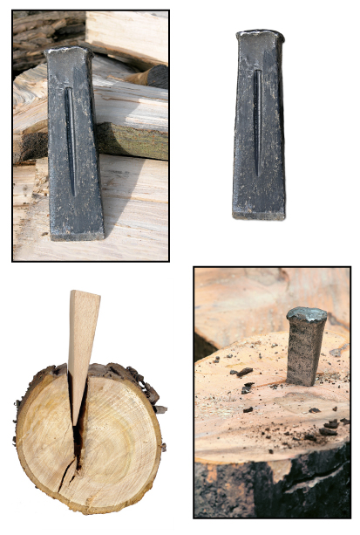  metal wedges: Adapted from iStockphoto/Thinkstock  wooden wedge: Hemera/Thinkstock
- n/a
Administrative Controls
- Provide initial training to include a thorough review of hazards and accidents associated with the job.
- Follow the school safety policy.
- Provide and document ongoing safety education and training, including mandatory equipment and tool orientation.
- Tag and remove defective tools from service.
- Ensure tools are used under competent supervision.
- Ensure the tool is appropriate for the work to be done.
- Ensure repetitive tasks are properly paced.
- Calculate the appropriate size and number of wedges required for a safe fall.
- Read and follow the manufacturer instructions, precautions, and directions for proper safety, maintenance, and cleaning.
- Establish handwashing practices
- Develop and communicate work practices and procedures for hazardous situations.

- Provide a first aid kit and supplies, including an eyewash station and biohazard disposal.
Personal Protective Equipment (PPE)
- forestry face shield
- hearing protection
- hard hat
- long-sleeved shirt
- loose-fitting trousers
- steel-toed boots with non-slip soles
- protective gloves
- chainsaw chaps
- respirator
- high-visibility jacket or vest when in the forest

