CLUSTER | NAT: NATURAL RESOURCES
OCCUPATION | Wildlife
HAZARD CONTROLS | TOOL—ARROW
Engineering Controls | 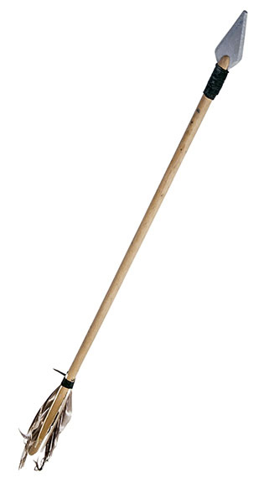  AbleStock.com/Thinkstock
- proper storage (e.g., avoid extreme temperatures or humidity)
Administrative Controls
- Follow the school safety policy.

- Provide and document ongoing safety education and training, including mandatory equipment and tool orientation.

- Tag and remove defective tools from service.

- Ensure the tool is appropriate for the work to be done.

- Schedule work to avoid overcrowding.

- Establish handwashing practices.

- Provide safe clearance for the tool.

- Provide a first aid kit and supplies, including an eyewash station and biohazard disposal.

- Keep the manufacturers’ manual for the tool. Read and follow manufacturer instructions, precautions, and directions for proper safety, storage (e.g., avoid extreme temperatures or humidity), maintenance, and cleaning.

- Provide initial training to include a thorough review of hazards and accidents associated with the task.

- Develop and communicate safe work practices and procedures for hazardous work or situations.

- Ensure repetitive tasks are properly paced.

- Maintain class supervision at all times.

- Keep the arrow in the quiver until ready to shoot the arrow.

- Ensure that the arrow is in good working order.

- Choose arrows that match the draw weight and draw length of the bow.

- Be sure that arrows are straight and their points are sharp and matched to the game being pursued.

- Assemble a repair and maintenance kit with spare parts and tools.
Personal Protective Equipment (PPE)
- arm guard
- finger protection
- mechanical release
- quiver

