CLUSTER | NAT: NATURAL RESOURCES
OCCUPATION | Wildlife
HAZARD CONTROLS | TOOL—BACKPACK
Engineering Controls | 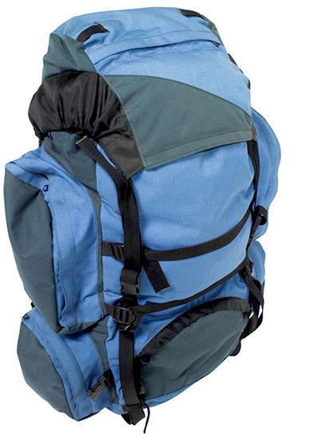  Stockbyte/Thinkstock
- n/a
Administrative Controls
- Choose a correctly sized backpack for the carrier.

- Teach safe packing techniques.

- Physically train and prepare students gradually to carry a backpack for a long period of time.

- Instruct students on wearing a backpack properly and using safe lifting and carrying techniques.

- Follow the school safety policy.

- Provide and document ongoing safety education and training, including mandatory equipment and tool orientation.

- Tag and remove defective tools from service.

- Ensure the tool is appropriate for the work to be done.

- Schedule work to avoid overcrowding.

- Establish handwashing practices.

- Provide safe clearance for the tool.

- Provide a first aid kit and supplies, including an eyewash station and biohazard disposal.

- Keep the manufacturer’s manual for the tool. Read and follow manufacturer instructions, precautions, and directions for proper use, safety, maintenance, and cleaning.

- Provide initial training to include a thorough review of hazards and accidents associated with the task.

- Identify and establish regular sanitary and safe housekeeping practices.

- Develop and communicate safe work practices and procedures for hazardous work or situations.
- Ensure repetitive tasks are properly paced.
Personal Protective Equipment (PPE)
- proper footwear

