CLUSTER | NAT: NATURAL RESOURCES
OCCUPATION | Wildlife
HAZARD CONTROLS | EQUIPMENT—BOAT
Engineering Controls | 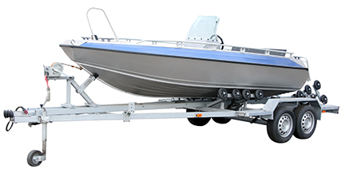  © kosanperm/37330163/Fotolia
- dry and well-ventilated storage area

- buoyant heaving line

- emergency kit

- boat safety equipment (type of equipment varies according to the type and size of craft being operated)

- distress equipment

- navigation equipment
Administrative Controls
- Teacher must be licensed as a Pleasure Craft Operator.

- Keep the manufacturer’s manual for the equipment. Read and follow manufacturer instructions, precautions, and directions for proper safety, maintenance, and cleaning instructions.

- Provide initial training to include a thorough review of hazards and accidents associated with the task.

- Follow the school safety policy.

- Provide and document ongoing safety education and training, including mandatory equipment and tool orientation.

- Tag and remove defective tools from service.

- Ensure the equipment is appropriate for the work to be done.

- Provide a first aid kit and supplies, including an eyewash station and biohazard disposal.

- Develop and communicate safe work practices and procedures for hazardous situations.

- Identify and secure materials that are the least toxic and harmful to the students and environment possible.

- Establish handwashing practices.

- Ensure repetitive tasks are properly paced.

- Teach emergency rescue procedures and the location of safety equipment.

- Life jackets or PFDs should be easily accessible by operator and passengers and kept away from gasoline or chemicals.

- Demonstrate the proper use of life jackets or PFDs.

- Adhere to the Competency of Pleasure Craft Regulations outlined in the Canada Shipping Act.

- Ensure the boat has a vessel capacity plate, which verifies the vessel meets Canadian construction standards and indicates various capacities of the boat, if the boat is over ten horsepower.

- Be aware that the type of safety equipment varies depending on the type and size of the craft being operated (includes boat safety equipment, distress equipment, and navigation equipment).

- Cover the motor once it is cool and not in use (propeller guard).
Personal Protective Equipment (PPE)
- personal floatation devices (PFD) or life jacket

