CLUSTER | NAT: NATURAL RESOURCES
OCCUPATION | Wildlife
HAZARD CONTROLS | EQUIPMENT— CANOE
Engineering Controls | 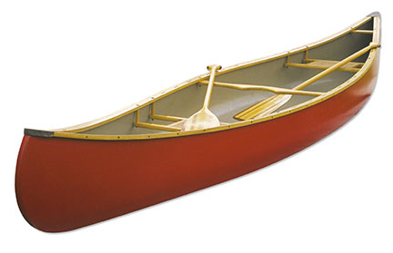  Comstock/Thinkstock
- dry and well-ventilated storage area
Administrative Controls
- Follow the school safety policy.

- Provide and document ongoing safety education and training, including mandatory equipment and tool orientation.

- Tag and remove defective tools from service.

- Ensure the equipment is appropriate for the work to be done.

- Schedule work to avoid overcrowding.

- Establish handwashing practices.

- Provide safe clearance for the equipment.

- Provide a first aid kit and supplies, including an eyewash station and biohazard disposal.

- Keep the manufacturer’s manual for the equipment. Read and follow manufacturer instructions, precautions, and directions for proper use, safety, maintenance, and cleaning.

- Provide initial training to include a thorough review of hazards and accidents associated with the task.

- Develop and communicate safe work practices and procedures for hazardous work or situations.

- Identify and secure cleaning materials that are less toxic and harmful to the students.

- Ensure repetitive tasks are properly paced.

- Instruct students to wear life jackets or PFDs.

- Life jackets or PFDs should be easily accessible by operator and passengers.

- Teach how to carefully load a canoe.
- Use paddling techniques that enhance stability and maneuverability.

- Teach when to stay off the water.

- Teach to always be prepared for the worst and have a plan in order to deal with the worst.

- Adhere to the Competency of Operators of Pleasure Craft Regulations outlined in the Canada Shipping Act.
Personal Protective Equipment (PPE)
- proper footwear, depending on the task
- extra set of dry clothes in waterproof container or bag

