CLUSTER | NAT: NATURAL RESOURCES
OCCUPATION | Wildlife
HAZARD CONTROLS | TOOL—CROSSBOW
Engineering Controls | 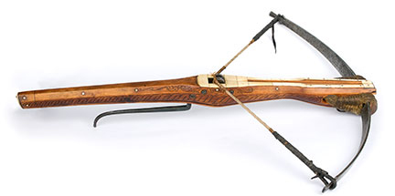  Hemera/Thinkstock
- machine guards

- proper storage (e.g., avoid extreme temperatures or humidity)
Administrative Controls
- Follow the school safety policy.

- Provide and document ongoing safety education and training, including mandatory equipment and tool orientation.

- Ensure the tool is appropriate for the work to be done.

- Schedule work to avoid overcrowding.

- Establish handwashing practices.

- Provide safe clearance for the tool.

- Provide a first aid kit and supplies, including an eyewash station and biohazard disposal.

- Keep the manufacturer’s manual for the tool. Read and follow manufacturer instructions, precautions and directions for proper safety, storage (e.g., avoid extreme temperatures or humidity), maintenance, and cleaning.

- Provide initial training to include a thorough review of hazards and accidents associated with the task.

- Develop and communicate safe work practices and procedures for hazardous work or situations.

- Ensure repetitive tasks are properly paced.

- Maintain class supervision at all times.

- Keep the arrow in the quiver until ready to shoot.

- Properly fit bow to meet legal and ethical requirements of the game that will be hunted.

- Ensure that the bow is in good working order.
- Tune the bow to the equipment you will be using for hunting.

- Assemble a repair and maintenance kit with spare parts and tools.

- Teach students to only hunt and shoot within their own physical limitations.
Personal Protective Equipment (PPE)
- arm guard
- finger protection
- mechanical release
- quiver
- protective eyewear

